BUCHANAN LECTURE 2026

The Zachry Department of Civil and Environmental Engineering at Texas A&M University is pleased to announce the 2026 Buchanan Lecture.

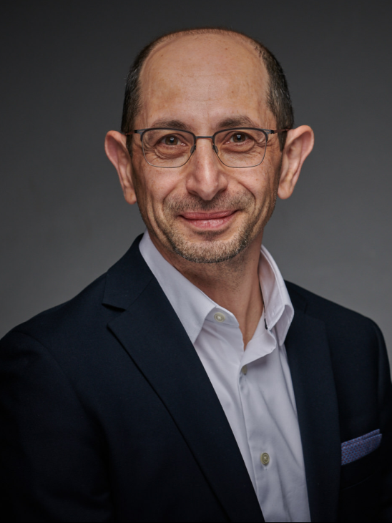
The 2026 Buchanan Lecturer is Dr. Youssef Hashash, Grainger Distinguished Chair of Engineering and Professor of Civil and Environmental Engineering at the University of Illinois Urbana-Champaign. The title of his lecture is “A new era of empiricism: The role of AI in Geotechnical Engineering with selected applications”. Dr. Hashash is internationally recognized for his contributions to geotechnical earthquake engineering, numerical modeling, tunneling, and excavation support systems. A Fellow of the American Society of Civil Engineers and former President of the ASCE Geo-Institute, he was elected to the National Academy of Engineering in 2022, one of the highest professional honors awarded to engineers in the United States.
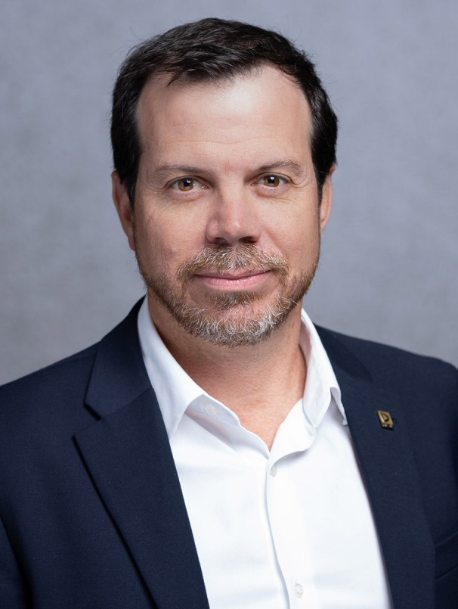
Also on the agenda is Dr. Rodolfo Sancio, Senior Principal Geotechnical Engineer and Operations Vice President at Geosyntec Consultants in Houston, Texas, who will present an Honor Lecture entitled “A Discussion on the Geotechnical Engineering State of the Practice.” Dr. Sancio has more than 25 years of professional experience in geotechnical engineering and geohazard management, with a strong emphasis on onshore and offshore infrastructure development. He is a recognized leader in geotechnical site characterization, geohazard assessment, and foundation engineering.

The lectures will take place on Friday October 23, 2026 at 2 pm.
in person at the Center for Infrastructure Renewal (CIR) on the Texas A&M RELLIS Campus:1041 RELLIS Pkwy, Bryan, TX 77807. A reception for all participants will follow the lectures at the Center for Infrastructure Renewal.

Best wishes, Jean-Louis.

Jean-Louis BRIAUD, PhD, PE
Distinguished Professor and Buchanan Chair Holder
Texas A&M University, College Station, Texas, 77843-3136, USA
Tel: 979-845-3795, Cell: 979-777-1692, Email: briaud@tamu.edu

